Task on App-server and Web-server

1) Install nginx and run nginx on port number 81.

2) Deploy a sample index.html file on nginx.

3) Install Apache and run Apache on port number 82.

4) Deploy a sample index.html file on Apache.

5) Install Apache tomcat on port number 8082

6) Deploy a sample app on webapps

7) Create a tomcat.service file for tomcat.

8) Configure HA Proxy server

**1) Install Nginx and Run on Port 81**

sudo apt update

sudo apt install nginx -y

To install Nginx and configure it to run on port 81, follow these steps:

1. Install Nginx:

For Debian/Ubuntu-based systems.

Code

sudo apt update  
 sudo apt install nginx

For RHEL/CentOS-based systems.

Code

sudo yum install nginx

(If nginx is not found, you may need to enable the EPEL repository first: sudo yum install epel-release)

2. Adjust Firewall (if applicable):

If you are using a firewall (like UFW on Ubuntu), you need to allow traffic on port 81. For UFW.

Code

sudo ufw allow 81/tcp  
 sudo ufw reload

3. Configure Nginx to Listen on Port 81:

* Open the default Nginx configuration file or create a new site configuration file. Common locations are /etc/nginx/sites-available/default or /etc/nginx/conf.d/default.conf.

Code

sudo nano /etc/nginx/sites-available/default

or

Code

sudo nano /etc/nginx/conf.d/default.conf

* Locate the server block and change the listen directive from 80 to 81.

Code

server {  
 listen 81;  
 listen [::]:81; # For IPv6, if desired  
 # ... other configurations  
 }

Save and close the file.

4. Test Nginx Configuration:

* Check for syntax errors in your Nginx configuration:

Code

sudo nginx -t

If there are no errors, you will see a message indicating the configuration is valid.

5. Restart Nginx:

* Apply the new configuration by restarting the Nginx service:

Code

sudo systemctl restart nginx

or

Code

sudo service nginx restart

6. Verify Nginx is Running on Port 81:

* Open your web browser and navigate to http://your_server_ip_address:81 or http://localhost:81 if you are on the server itself. You should see the Nginx welcome page or the content of your configured web root.
* 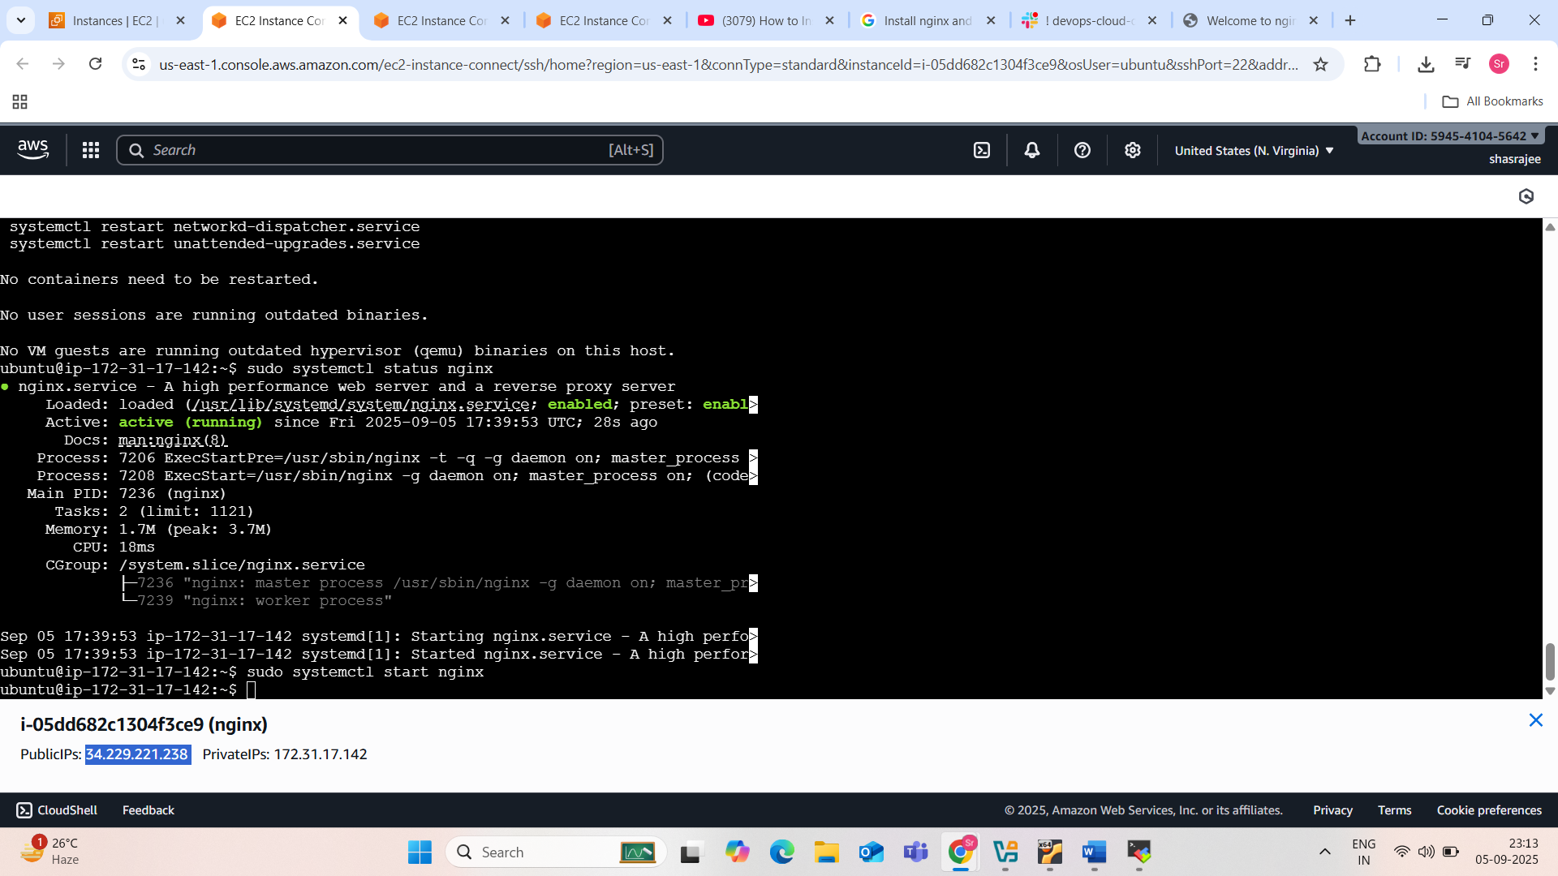
* 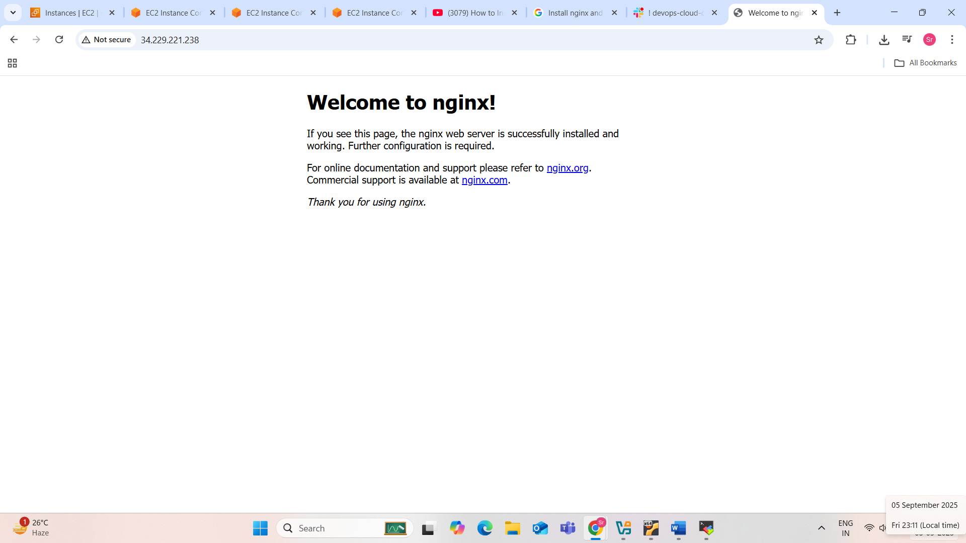

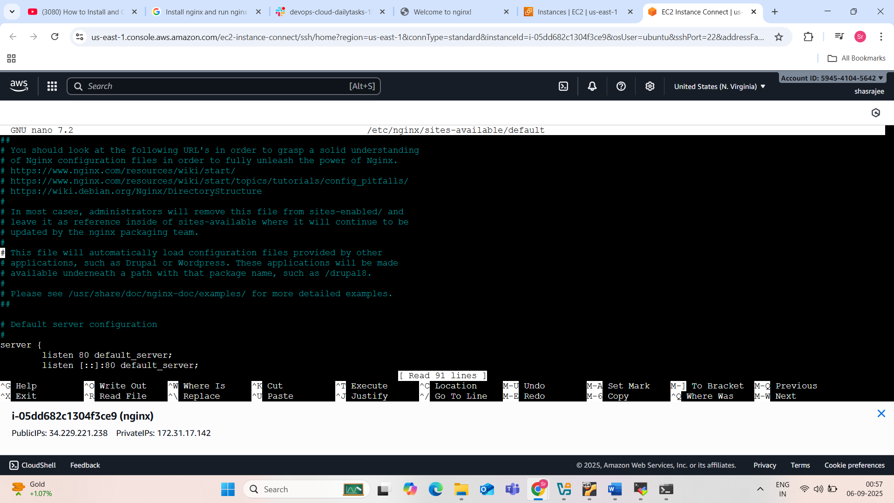

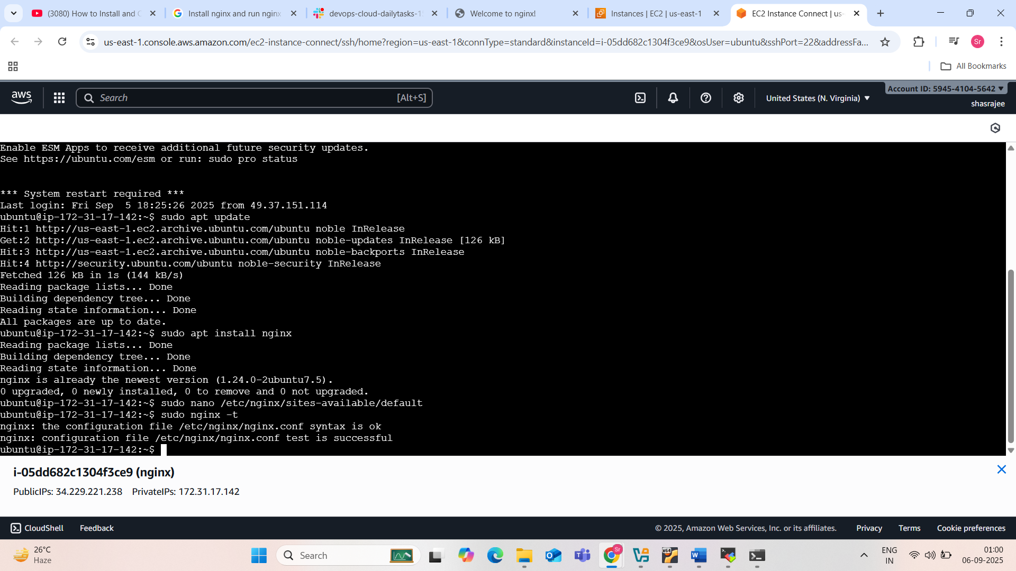

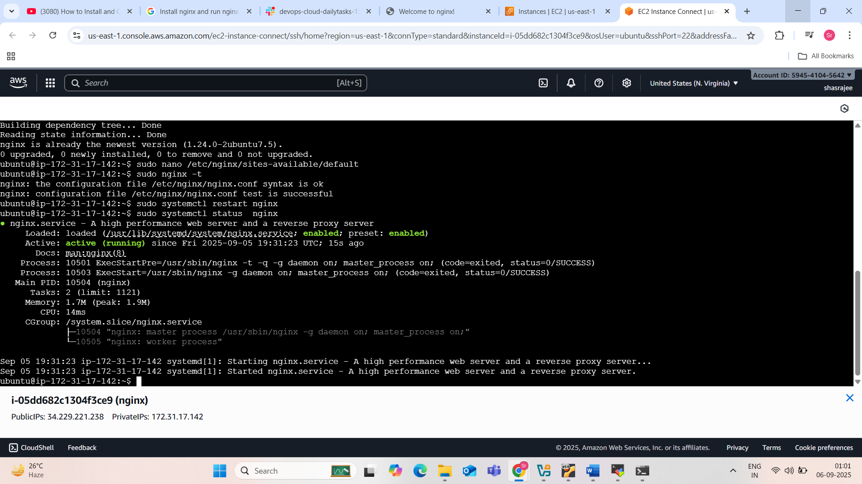

Change the port number 80 to 81 ..now the nginx server will run on 81 port

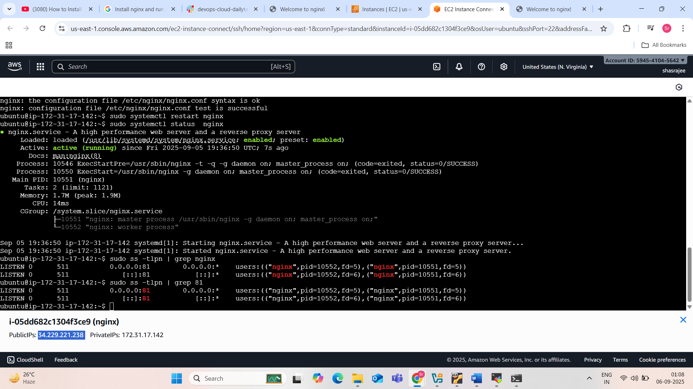

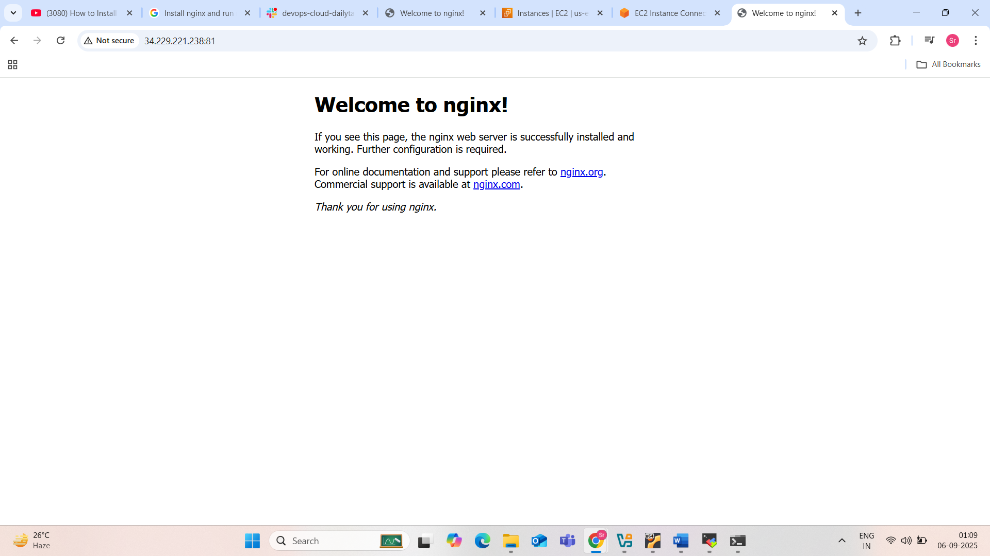

2) Deploy a sample index.html file on nginx.

To deploy a sample index.html file on Nginx, follow these steps: Create the index.html file.

Create a file named index.html in your desired web root directory. A common location for Nginx is /var/www/html/.

Code

<!DOCTYPE html>  
 <html lang="en">  
 <head>  
 <meta charset="UTF-8">  
 <meta name="viewport" content="width=device-width, initial-scale=1.0">  
 <title>Nginx Sample Page</title>  
 </head>  
 <body>  
 <h1>Hello from Nginx!</h1>  
 <p>This is a sample index.html page served by Nginx.</p>  
 </body>  
 </html>

Place the index.html file.

Copy the created index.html file into the Nginx web root directory. If you are using the default Nginx configuration on a Linux system, this is typically /var/www/html/.

Code

sudo cp index.html /var/www/html/

Ensure Nginx is running and configured.

Nginx should be installed and running. The default Nginx configuration usually serves files from /var/www/html/ automatically. You can verify the Nginx service status:

Code

sudo systemctl status nginx

If Nginx is not running, start it:

Code

sudo systemctl start nginx

Access the page.

Open your web browser and navigate to the IP address or domain name where Nginx is hosted. For example, http://localhost/ or http://your_server_ip/. You should see the content of your index.html file.

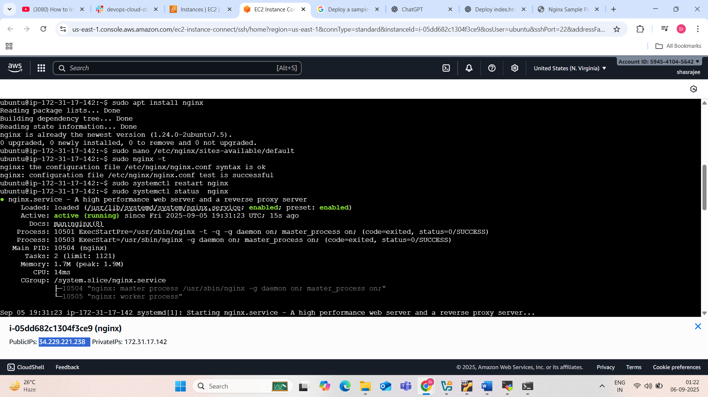

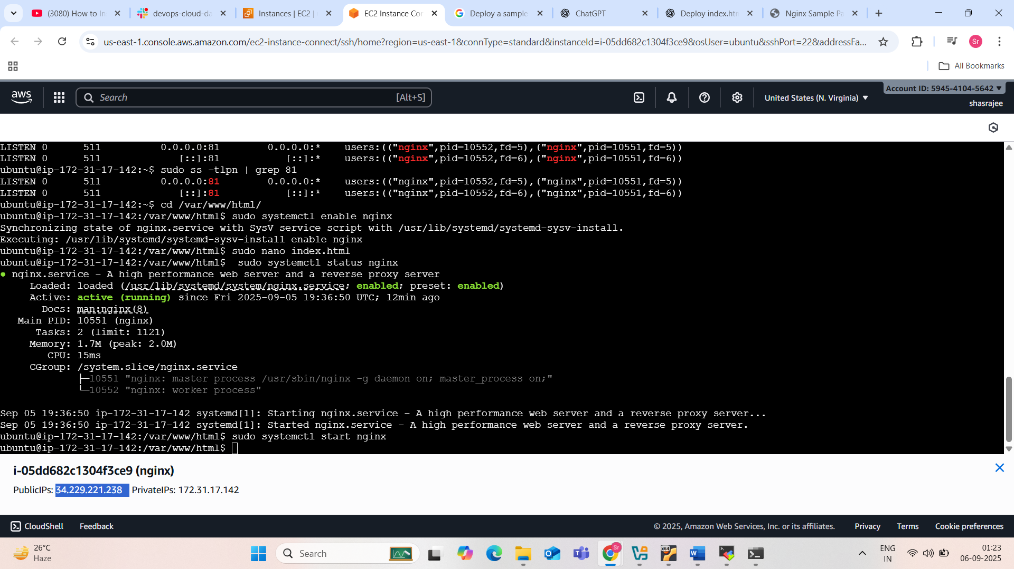

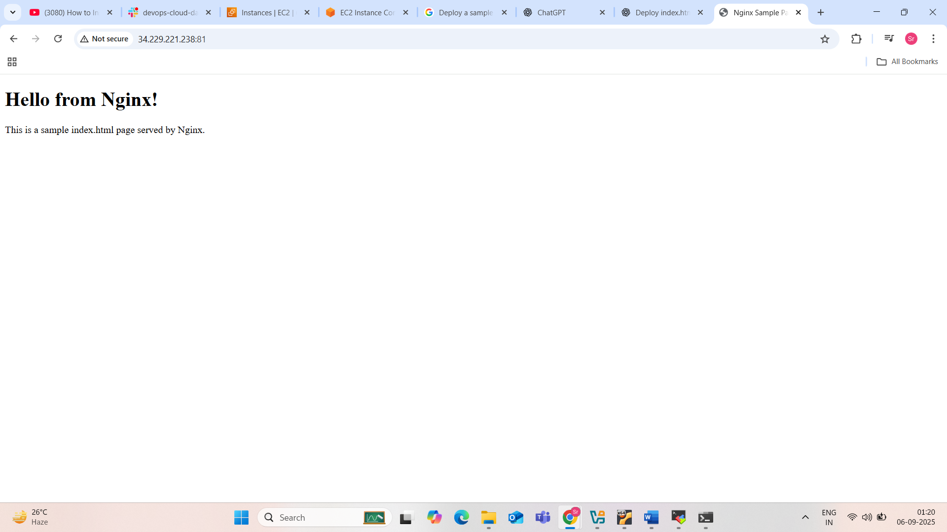

. 3) Install Apache and run Apache on port number 82

To install apache

Sudo install apache…before this we need to update and upgrade the connected apache server from aws

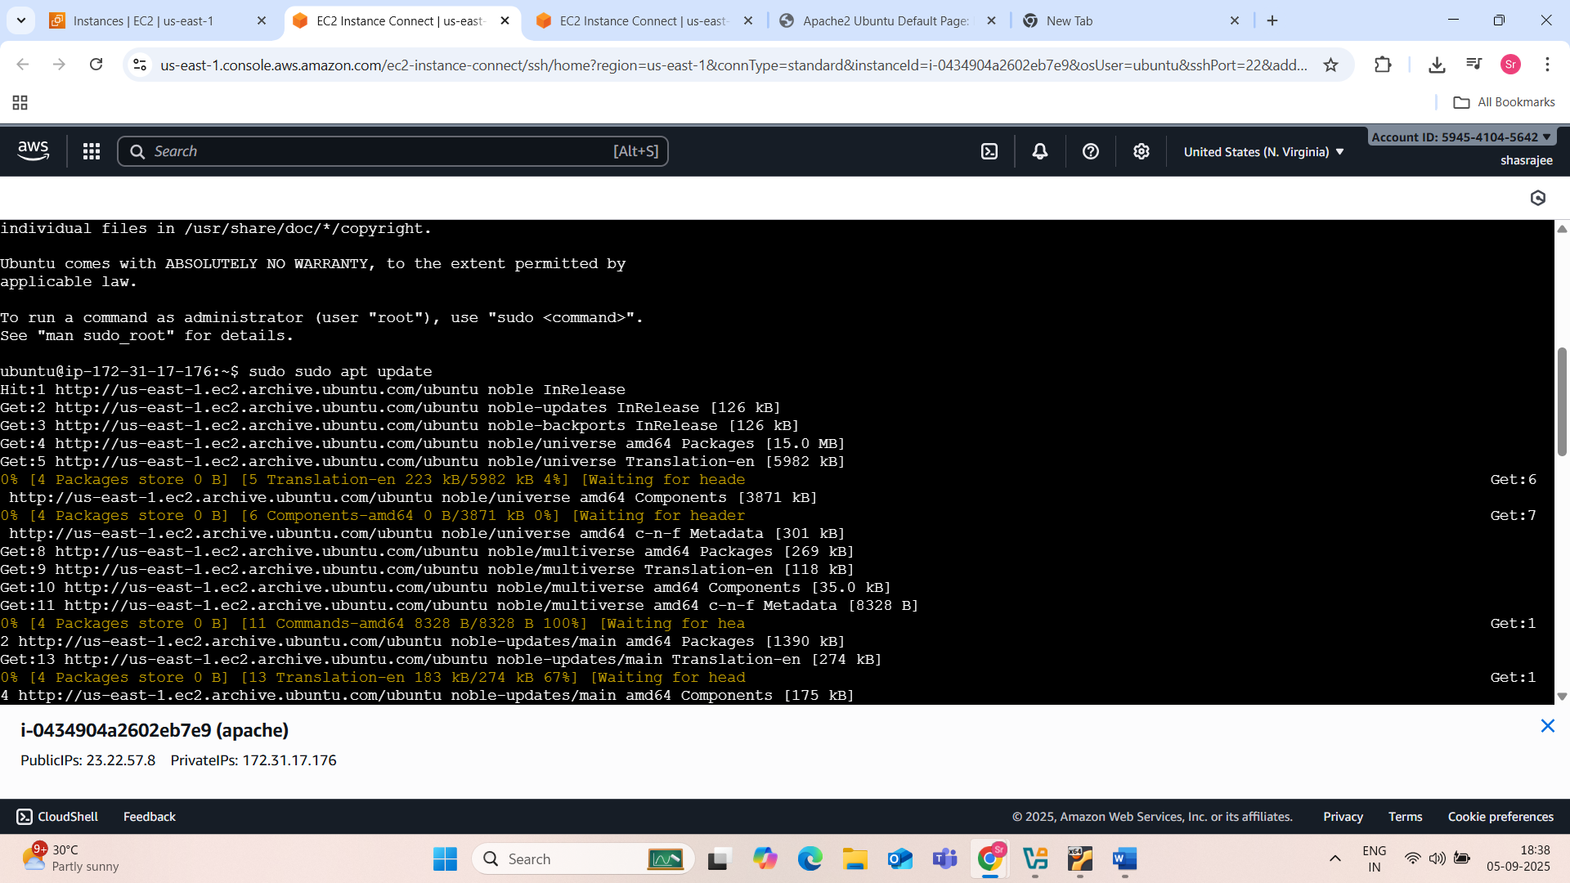

Figure : sudo update apache

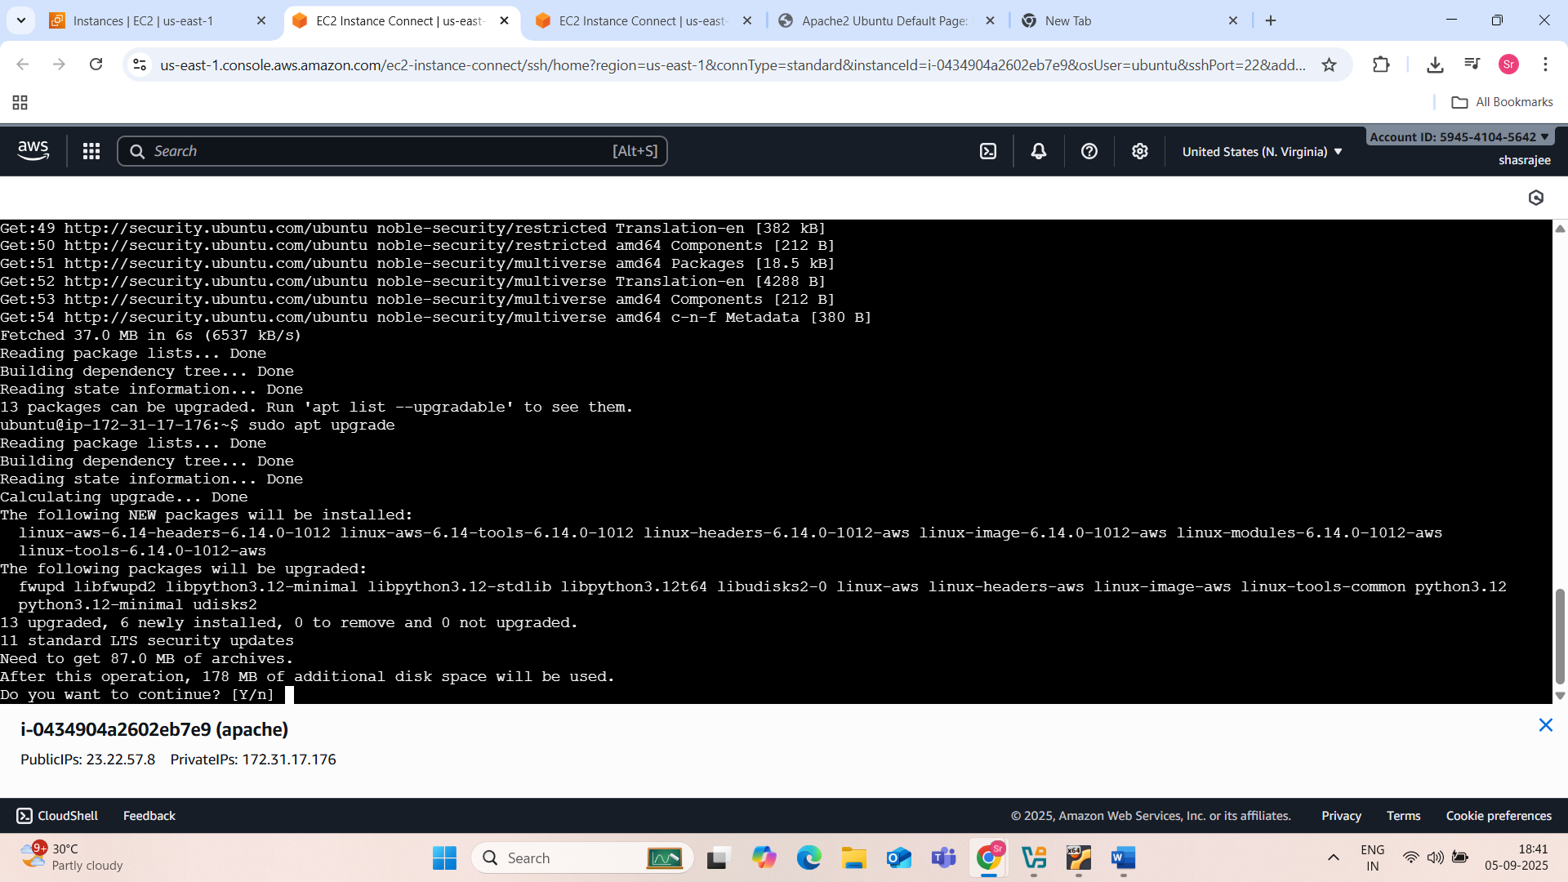

Figure :sudo upgrade apache

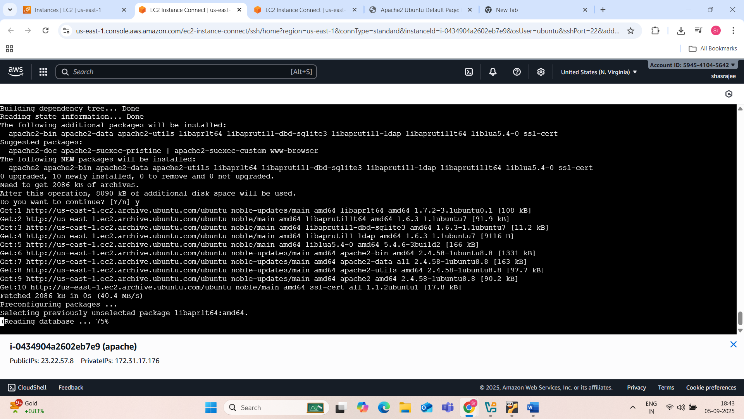

Figure :sudon apt install apache2

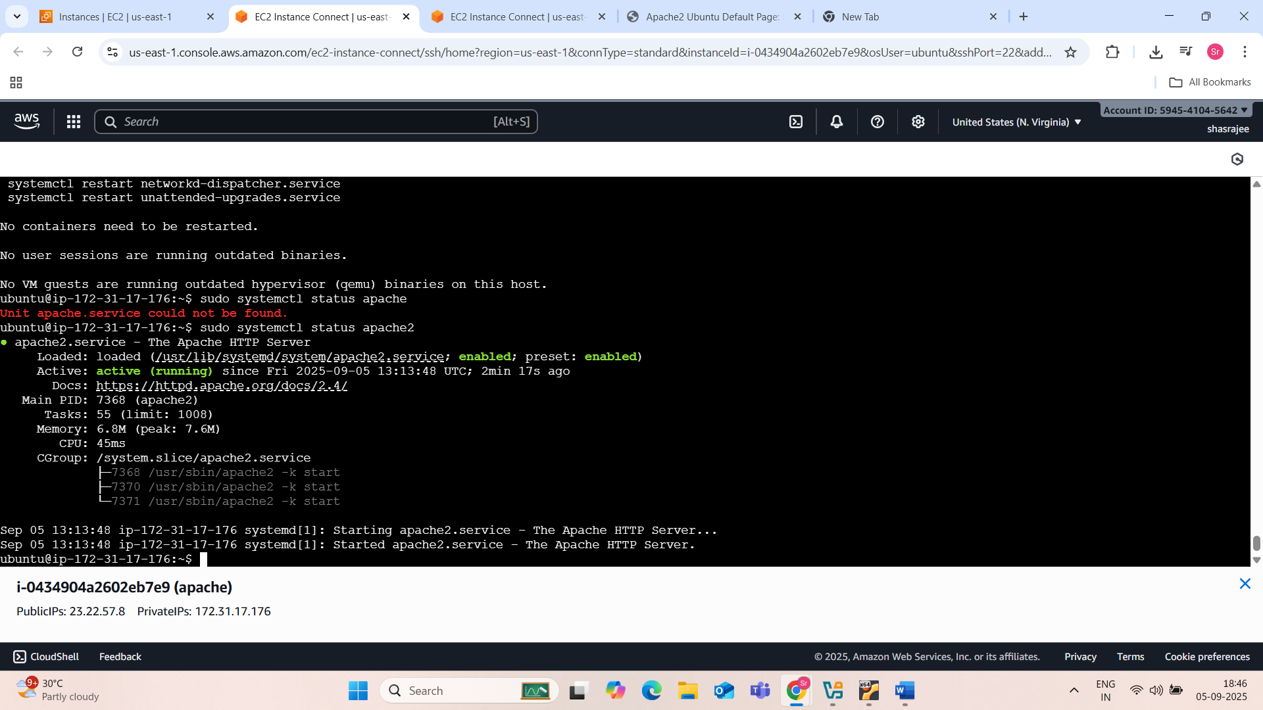

Figure :sudo systemctl status apache2

Next copy the ipadress of apache2 installed and open the webbrowser and paste the address and add :80 and enter ,you will find the apache2 default page.

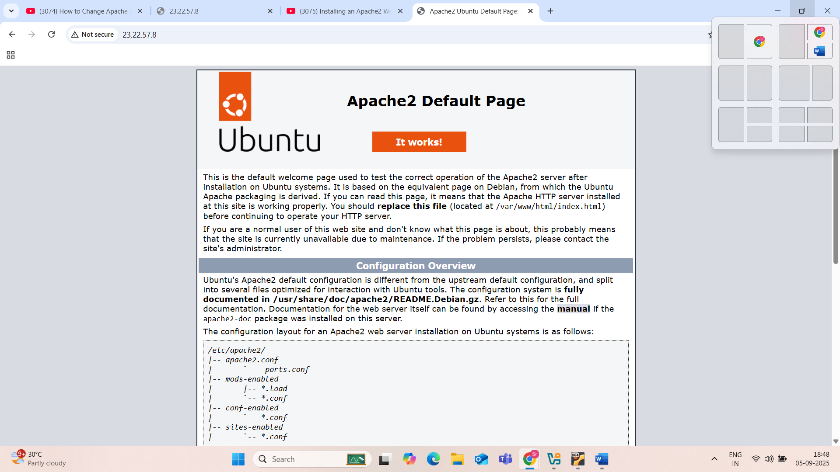

Figure :apache2 defaultpage

NOW RUN APACHE2 ON PORT NUMBER 8089

Change the directory …cd /etc/apache2/ and see the list of files by command ls

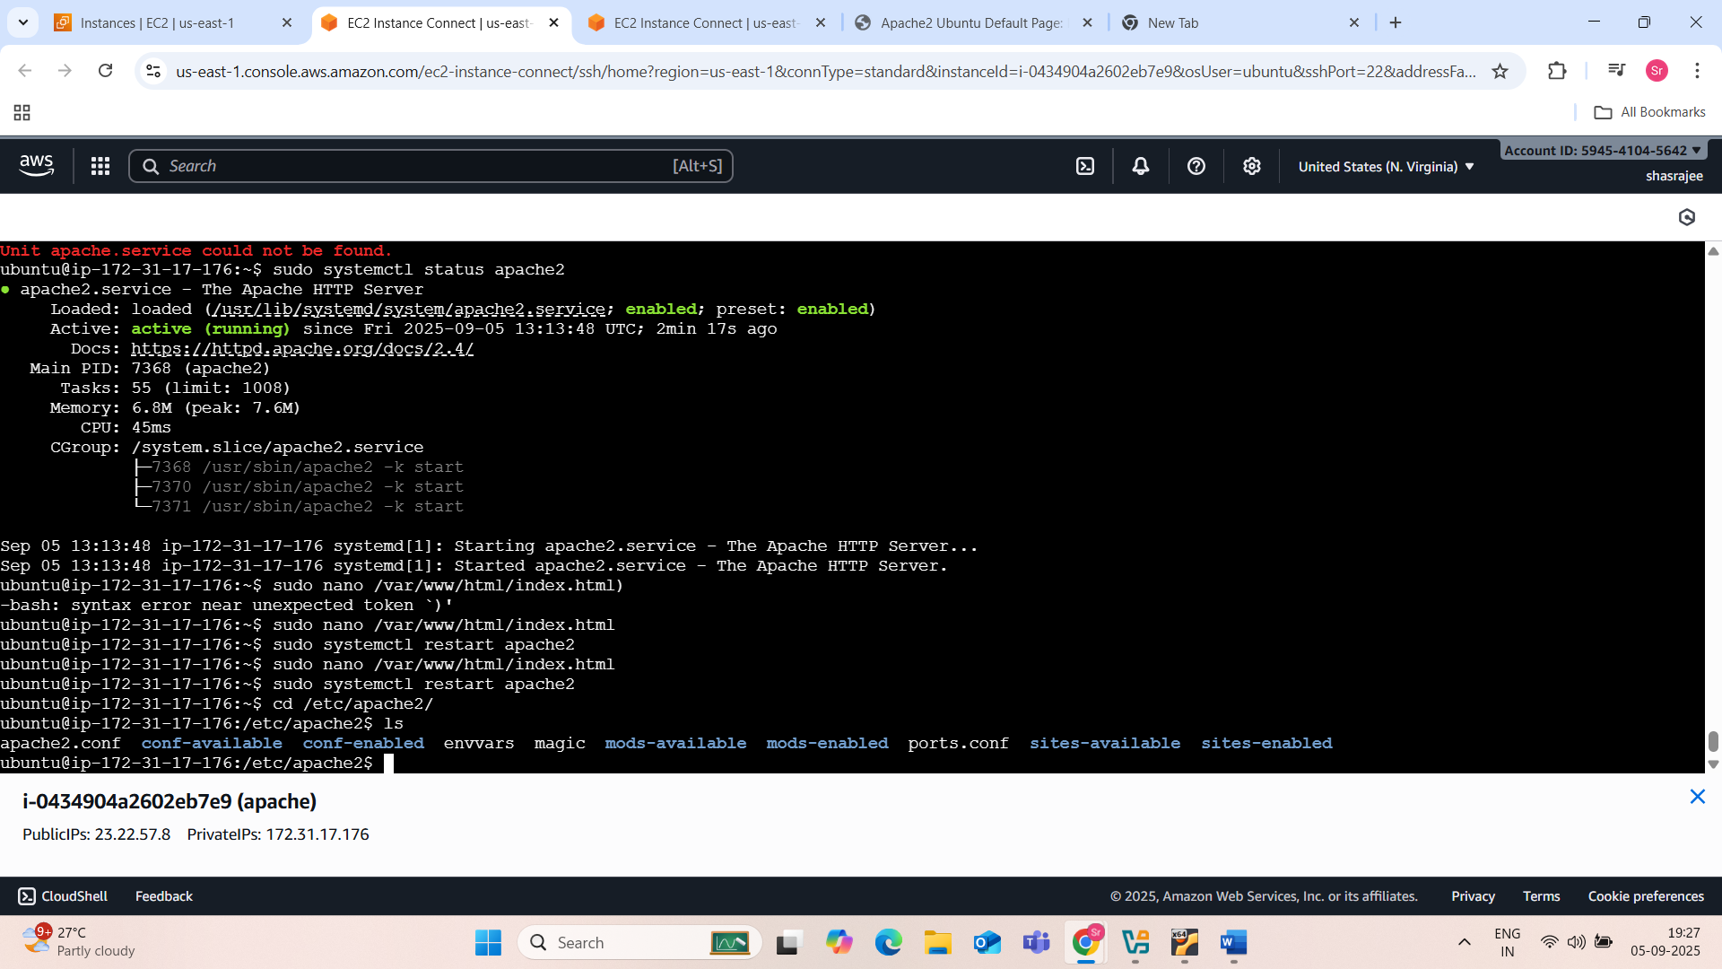

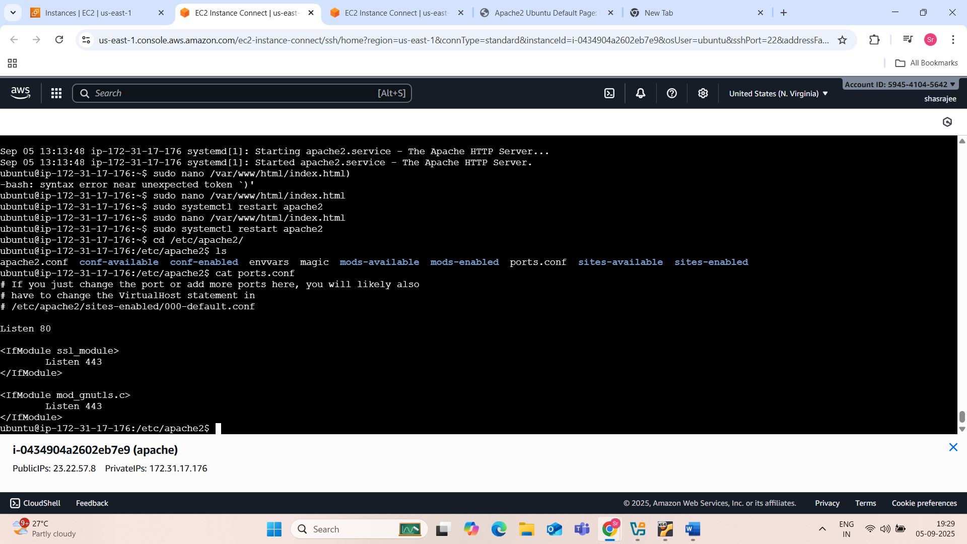

By using sudo nano ports.conf command edit the port num listen 80 to listen 8089

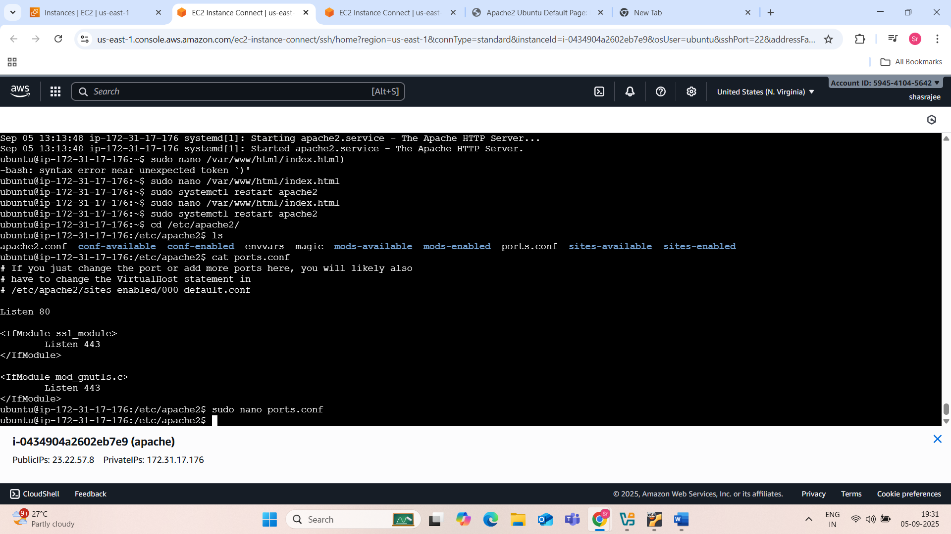

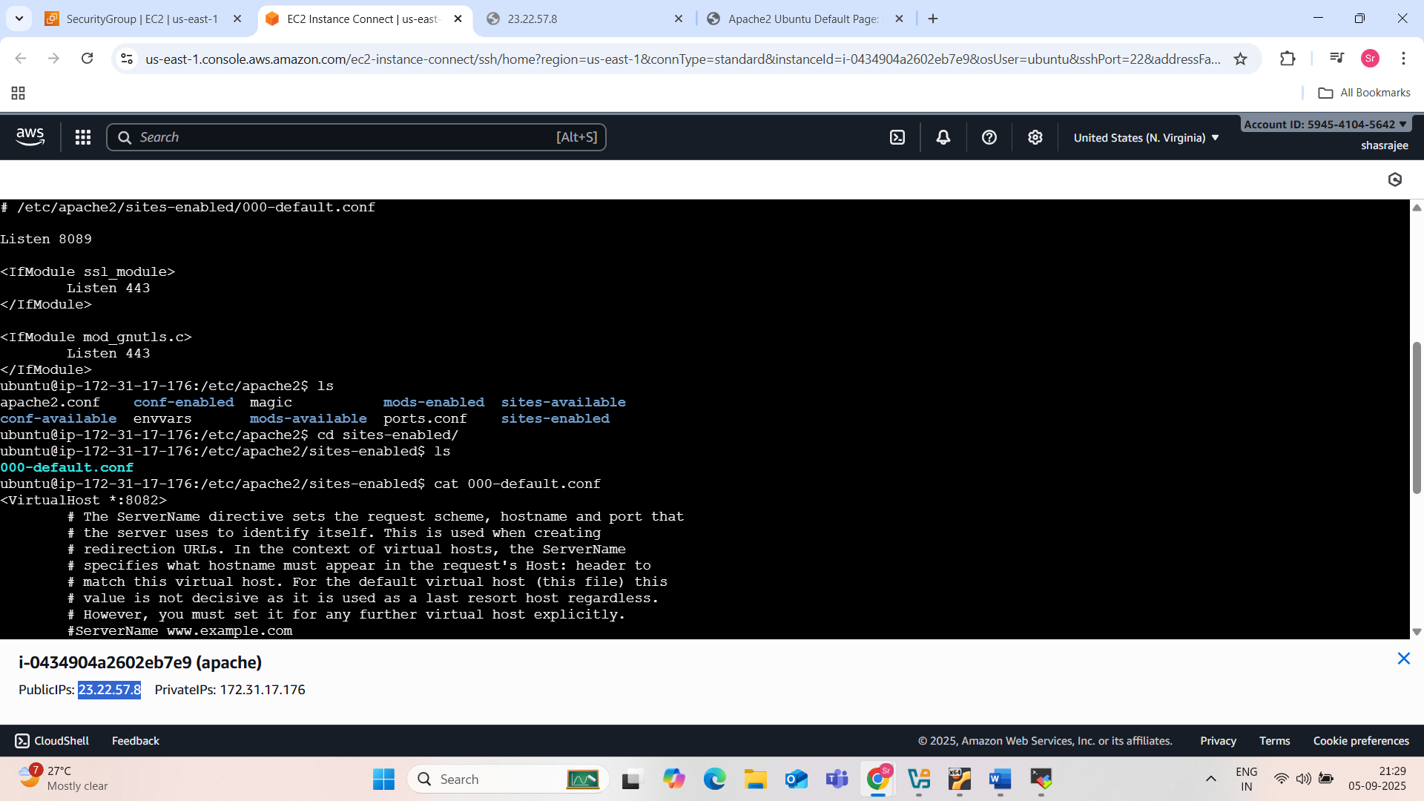

See the list of files by using ls command

Cd sites-enabled/

Ls

Cat 000-default.conf

And see the virtual host is running on 80….<virtualHost *:80>…now u need to change this portnum to 8089 by using command sudo nano 000-default.conf

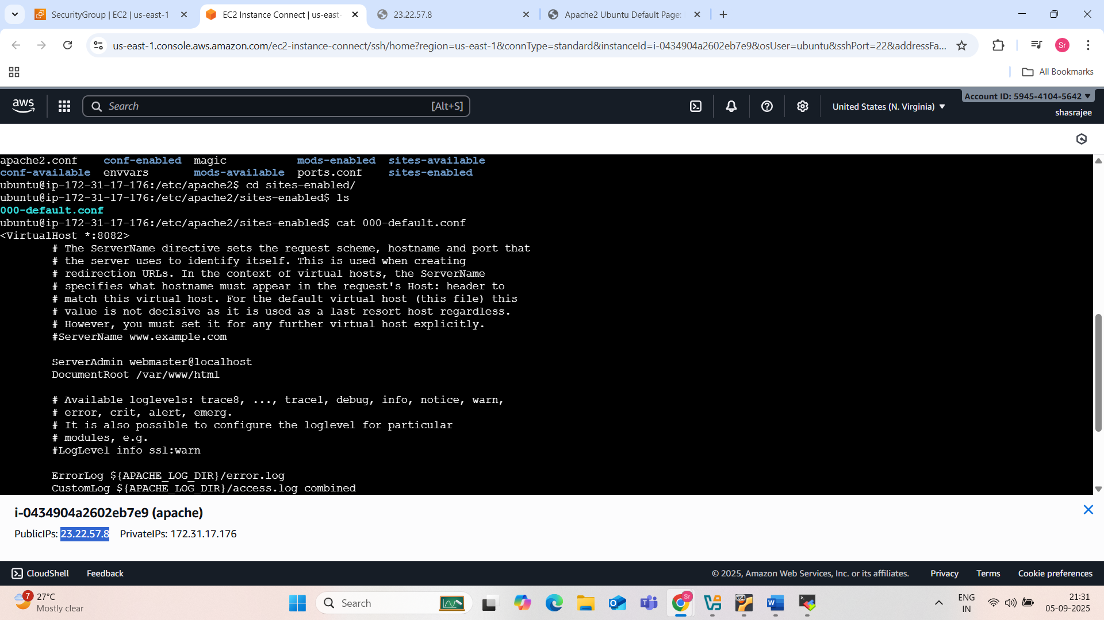

Now restart the apache2 …command sudo systemctl restart apache2

Next copy the ipaddress and go to web brower and paste it and add :8089 and search.

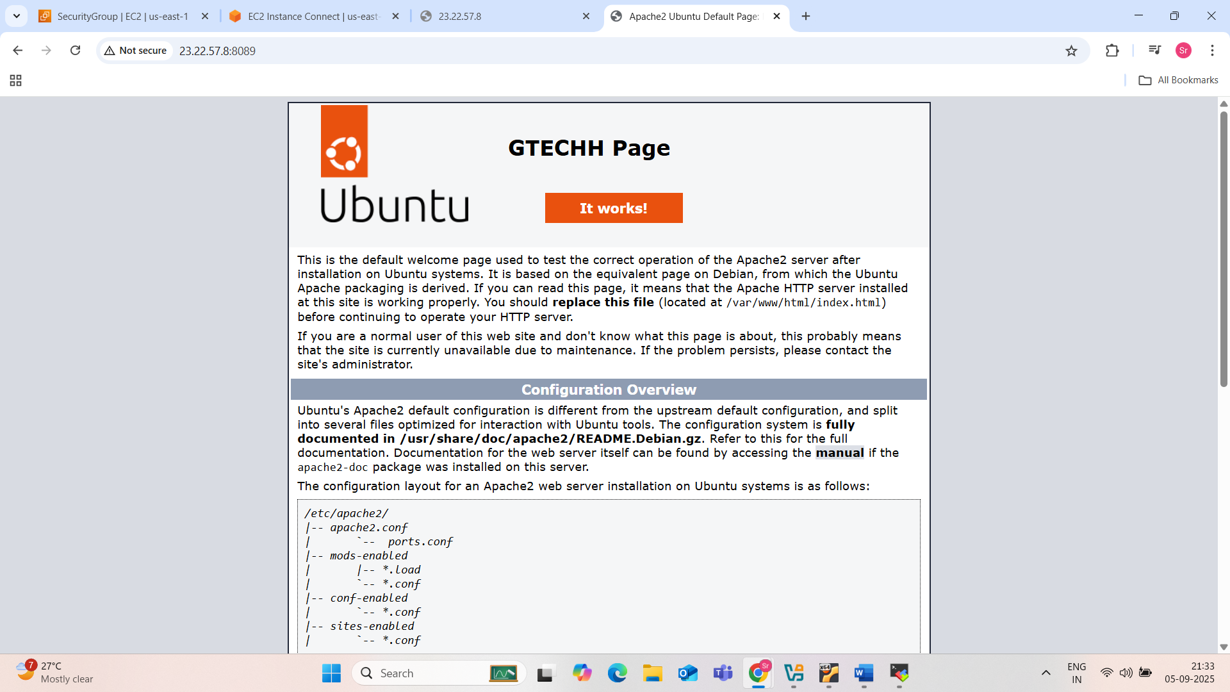

If I want to edit the content….sudo nano /var/

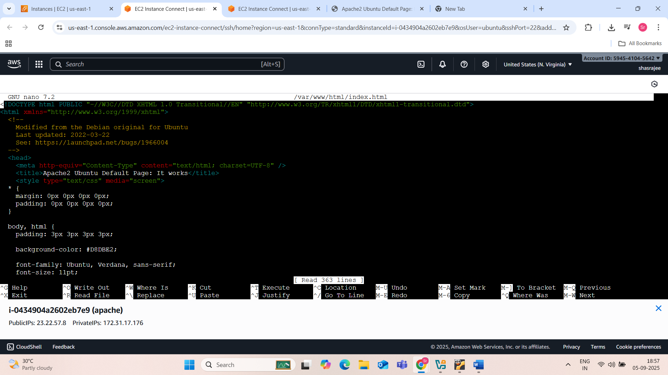

Figure :html page of apache2

Edit the content by using sudo nano /var/

I edited the apache2 ubuntu default page to GTECHH PAGE

Save the chaged content and ctrl+x and enter y and exit restart the apache2 by entering sudo apt restart apache2 and go to web brower and resh on the apache2 default page….now you can see the edited page i.e GTECHH PAGE

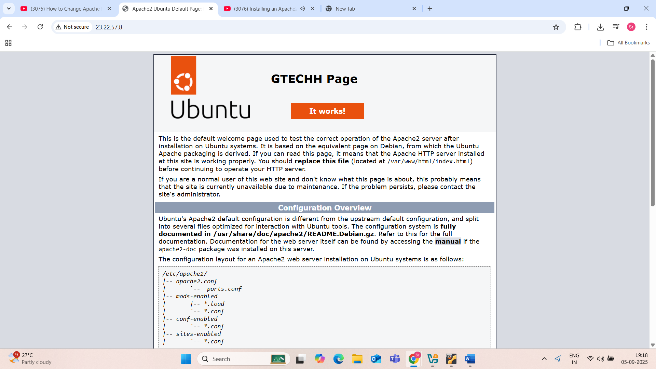

4) Deploy a sample index.html file on Apache

To deploy a sample index.html file on Apache, follow these steps:

* **Ensure Apache is running:**

Verify that your Apache web server is active. You can typically check its status and start it if needed using commands like sudo systemctl status apache2 and sudo systemctl start apache2 on Linux systems.

* **Navigate to the document root:**

The default directory where Apache serves web content is usually /var/www/html/. Use the command cd /var/www/html to navigate to this directory.

* Create or modify index.html:
  + If an index.html file already exists in this directory, you can either rename it (e.g., mv index.html index.html.bak) or delete it (rm index.html) if you no longer need its content.
  + Create a new index.html file or open the existing one for editing using a text editor like nano: nano index.html.
* **Add sample HTML content:**

Paste or type your desired HTML content into the index.html file. For a simple example:

Code

<!DOCTYPE html>  
 <html>  
 <head>  
 <title>My Sample Page</title>  
 </head>  
 <body>  
 <h1>Hello, Apache!</h1>  
 <p>This is a sample index.html page deployed on Apache.</p>  
 </body>  
 </html>

* **Save the file:**

If using nano, press Ctrl+O to save, then Enter to confirm the filename, and Ctrl+X to exit.

* **Access the page:**

Open your web browser and navigate to http://localhost/ (if Apache is running on your local machine) or http://your_server_ip_address/ (if accessing from another machine) to view your deployed index.html file.

Commands used:

Sudo systemctl status apache2

Sudo systemctl start apache2

Cd /var/www/html

Sudo nano index.html

And I moved the existing content by command: sudo  mv index.html index.html.bak

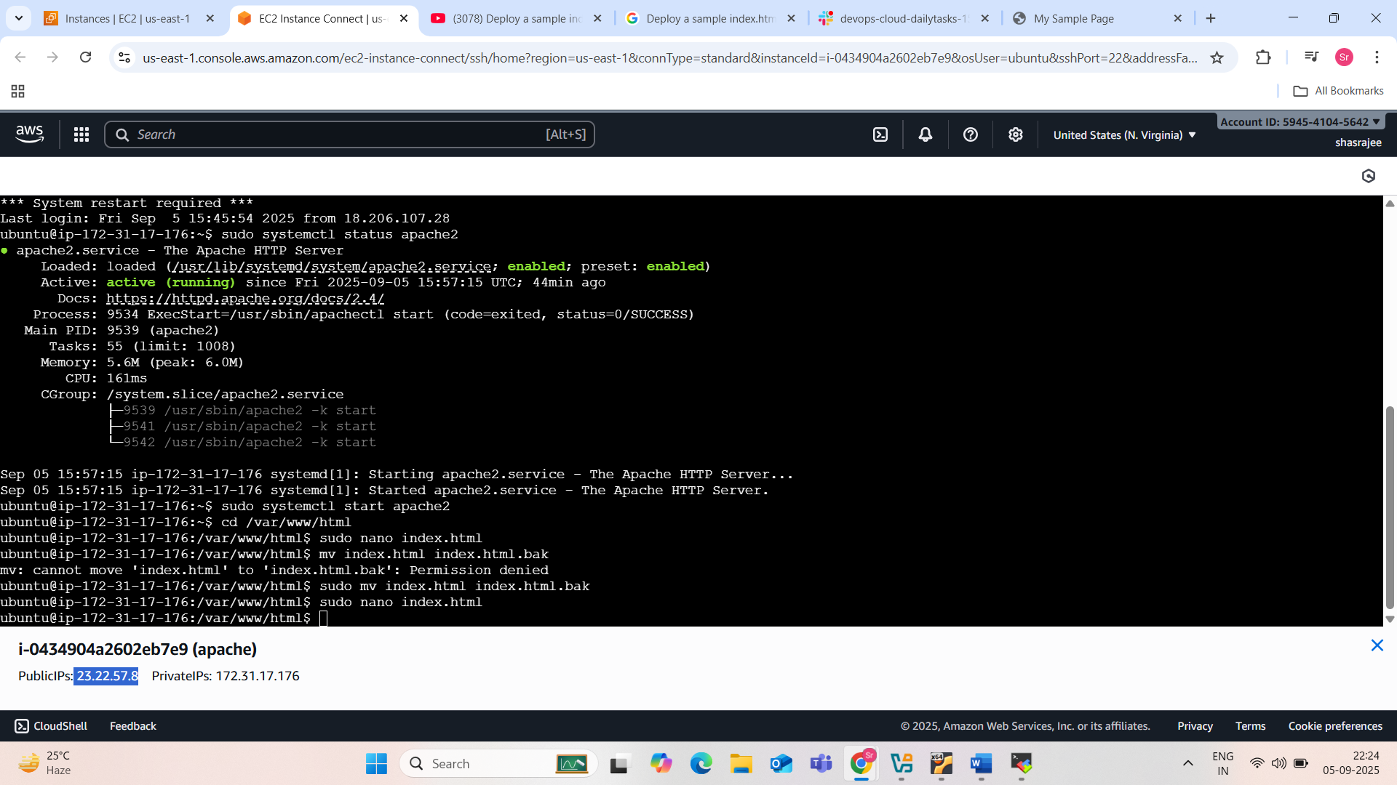

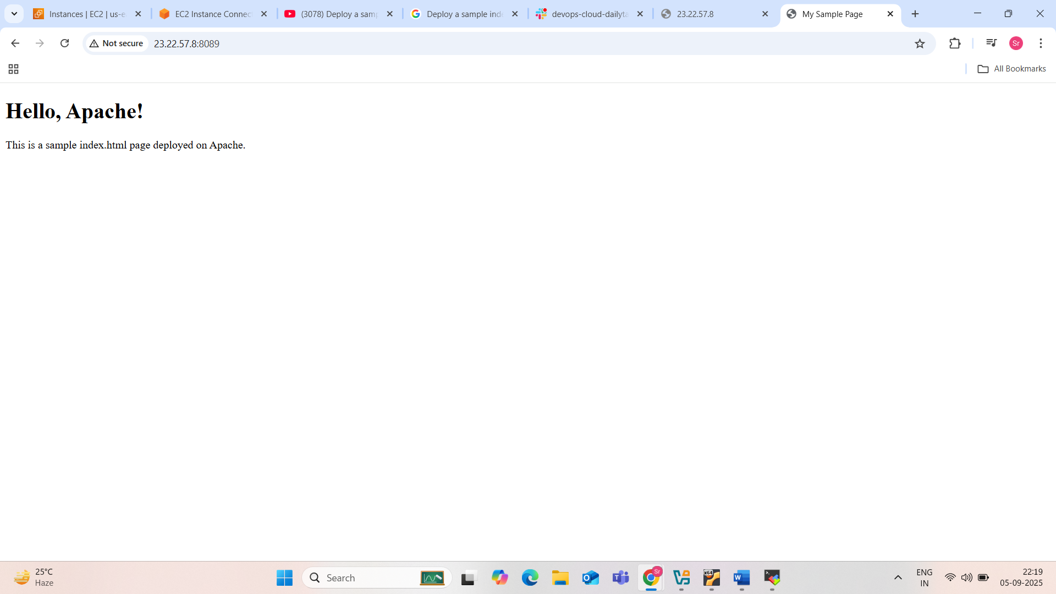

5) Install Apache tomcat on port number 8082

* **Install Apache Tomcat:**
  + **Windows:** Run the downloaded installer. During the setup process, you will be prompted to configure various settings. Crucially, when asked about the HTTP Connector port, change the default (usually 8080) to 8082. Complete the installation by following the on-screen instructions, including setting an administrator username and password if desired, and selecting the JDK path.
  + **Linux/macOS:** Extract the downloaded tar.gz archive to your desired installation directory (e.g., /opt/tomcat).
* **Configure Port 8082 (if not set during installation):**
  + Navigate to the conf directory within your Tomcat installation (e.g., C:\Program Files\Apache Software Foundation\Tomcat\conf on Windows, or /opt/tomcat/conf on Linux).
  + Open the server.xml file in a text editor.
  + Locate the <Connector> element that defines the HTTP connector. It typically looks like this:

Code

<Connector port="8080" protocol="HTTP/1.1"  
 connectionTimeout="20000"  
 redirectPort="8443" />

* Change the port attribute value from 8080 to 8082.

Code

<Connector port="8082" protocol="HTTP/1.1"  
 connectionTimeout="20000"  
 redirectPort="8443" />

Save the server.xml file.

* **Start Apache Tomcat:**
  + **Windows:** Find the Apache Tomcat service in the Windows Services manager and start it, or use the startup.bat script in the bin directory of your Tomcat installation.
  + **Linux/macOS:** Navigate to the bin directory within your Tomcat installation and execute ./startup.sh.
* **Verify Installation:**
  + Open a web browser and navigate to http://localhost:8082. You should see the Apache Tomcat welcome page, confirming that Tomcat is running and accessible on port 8082.

Apache tomcat on port num 8082: in windows

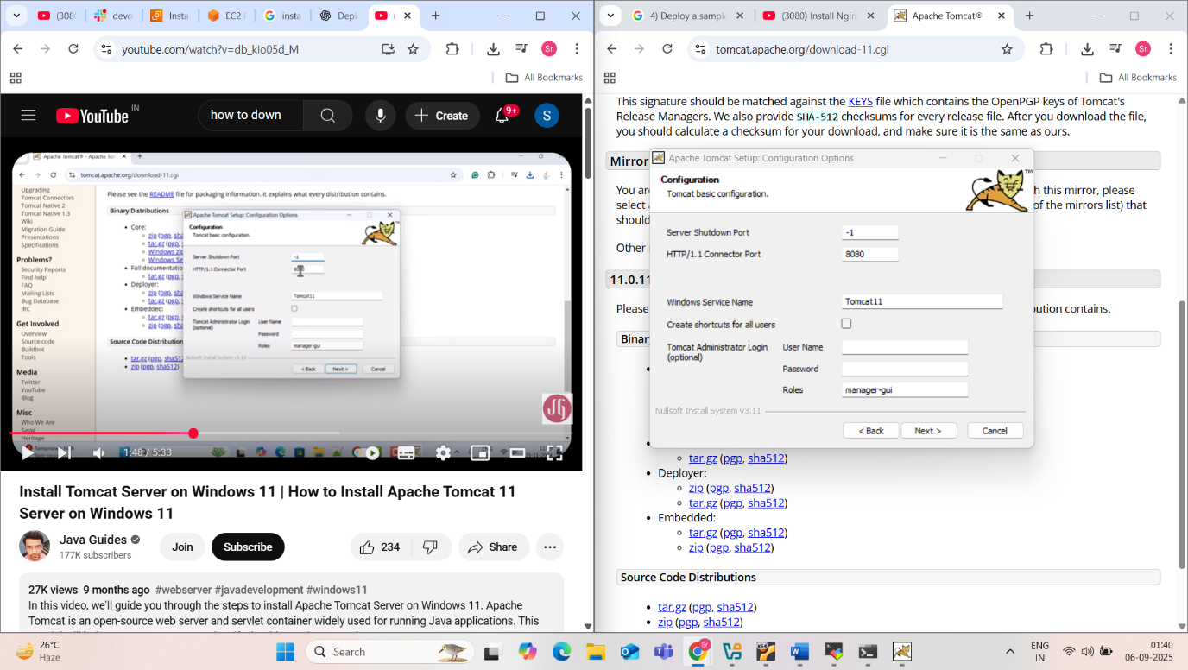

Figure :Apache tomcat on port:8080

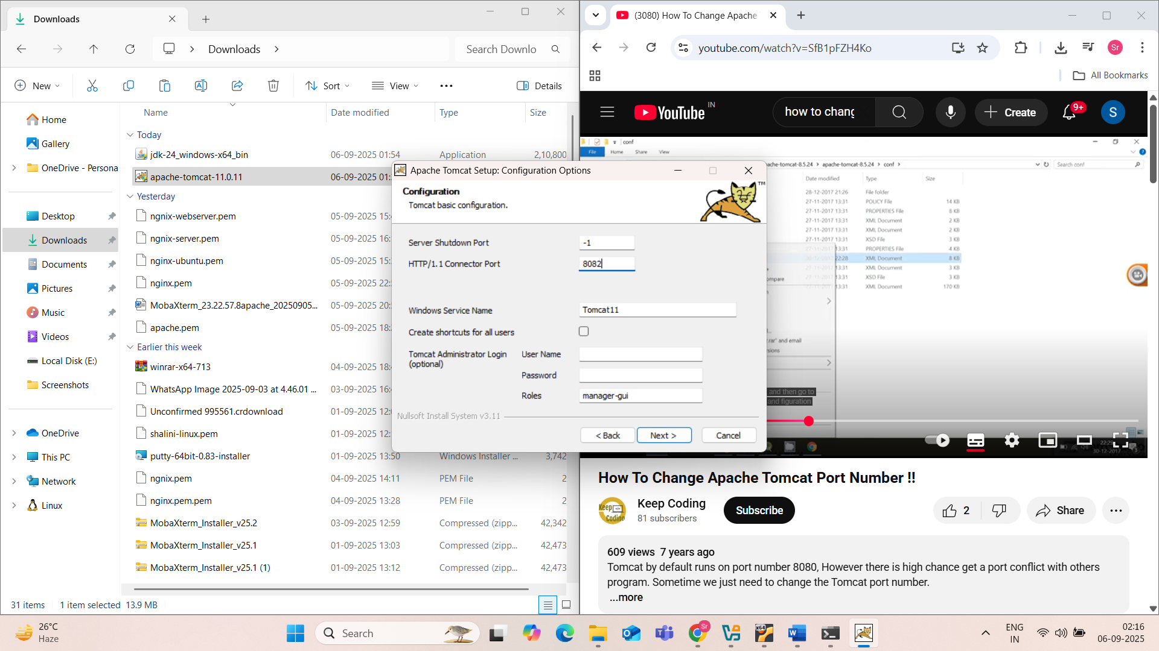

Figure :changed port num from 8080 to 8082

Apache tomcat on port num 8082: in aws-linux

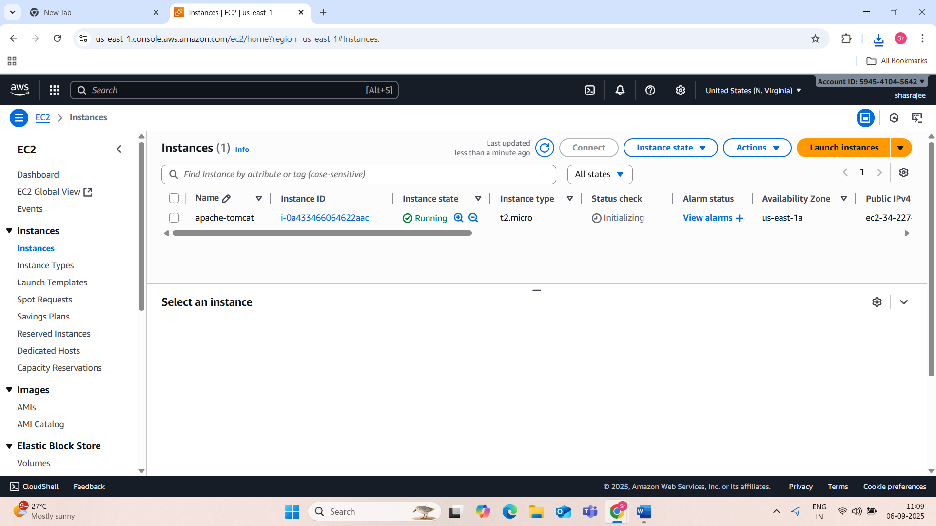

Figure 9:lanch-instance instane

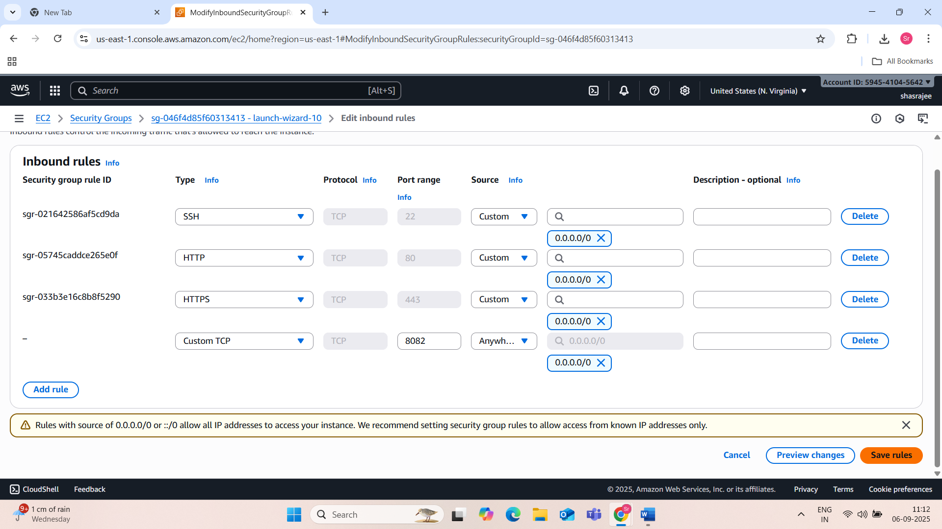

Figure 10: goto security-securitygroup-add rule for port8082 access

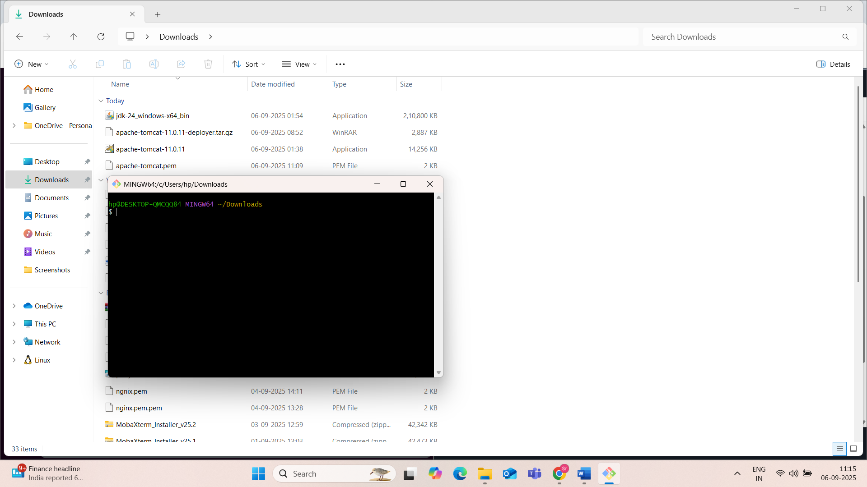

Figure 11:go to downloads where apache-tomcat keypair is downloaded and click on apache-tomcat.pem and righ click and open Gitbash terminal

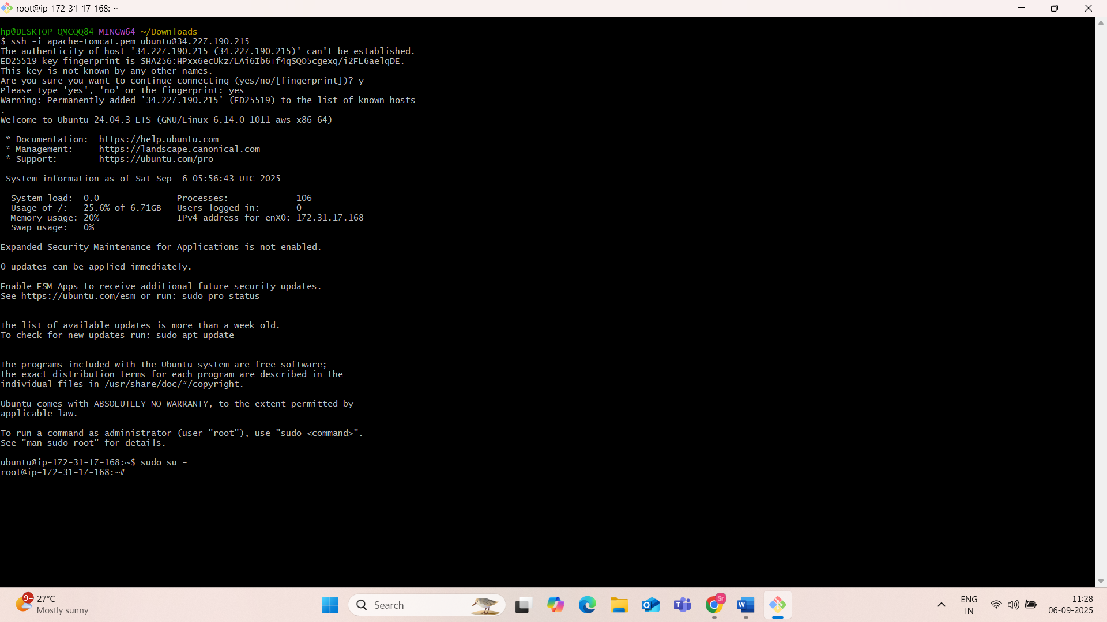

Figure 12:aws ec2 ubuntu launch machine connected

Sudo su -: this will switch to root user

Installation of java:

Before installation update your package list: sudo apt update

Install java: yum install java

(if u want to see the java version :)

Verify installation:java -version

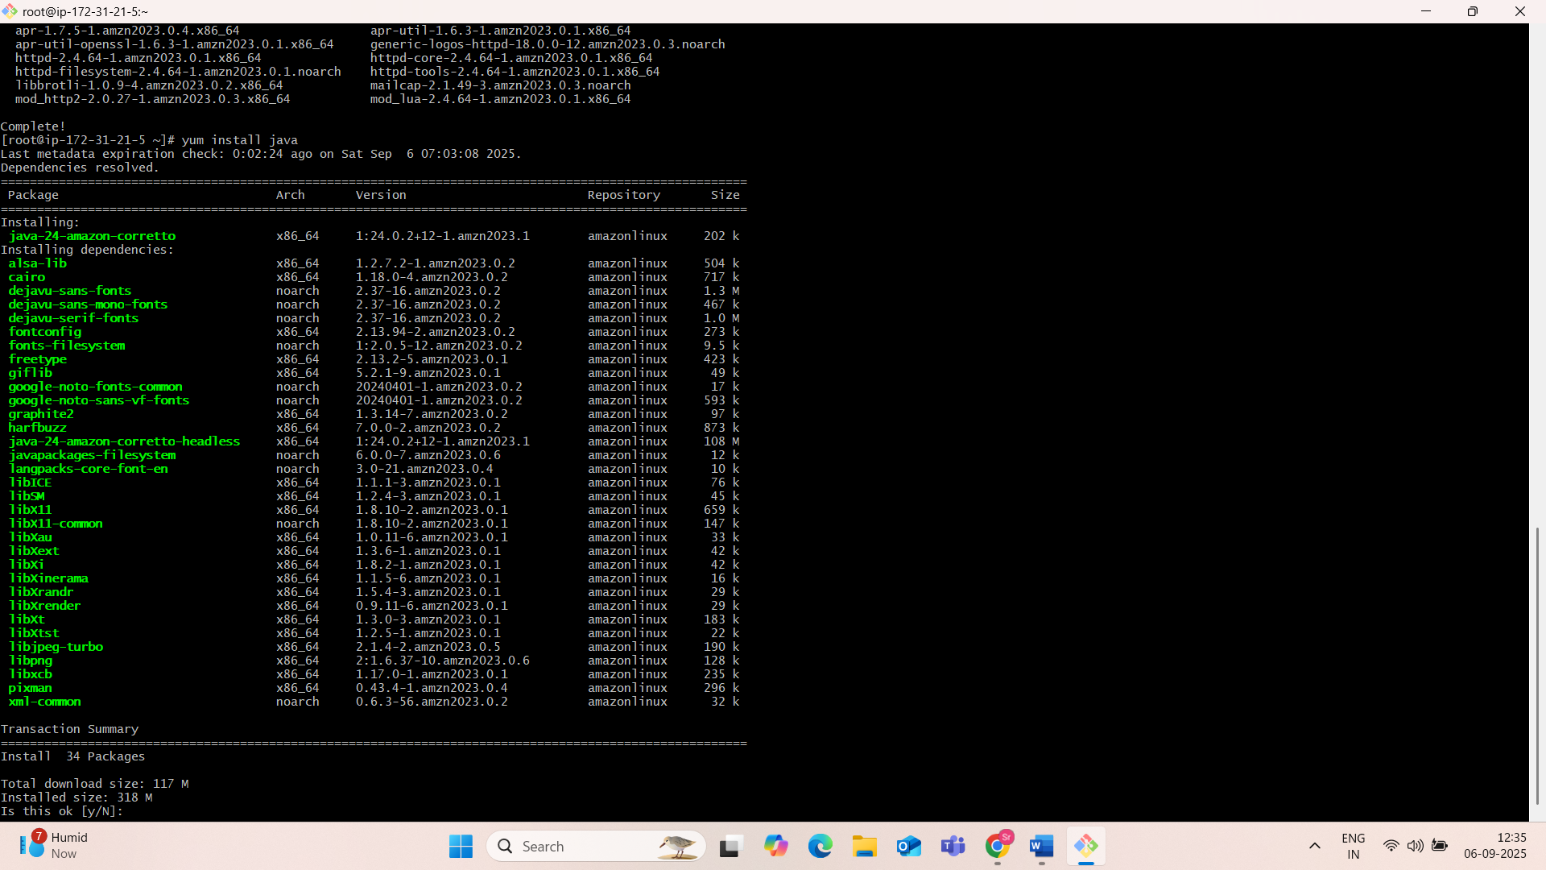

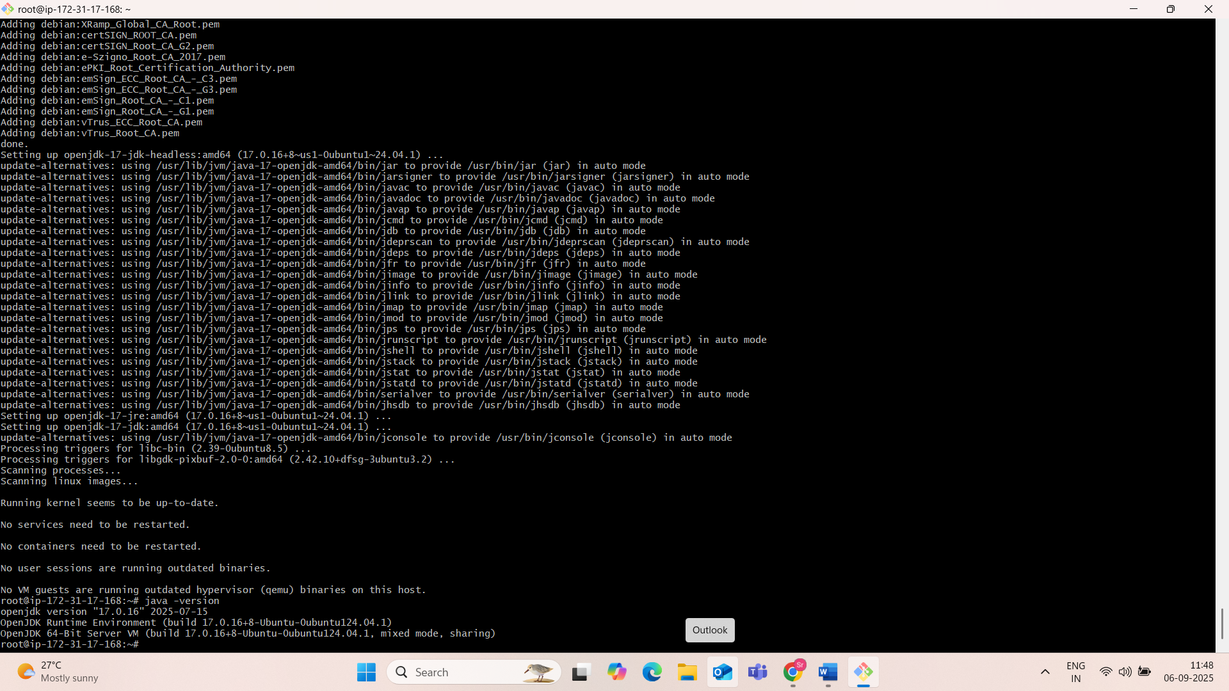

Goto apache download and tomcat11 and copy the address link in core tar or zip..

Open terminal chane the directory: cd /opt

) Deploy a sample app on webapps

Wget <https://dlcdn.apache.org/tomcat/tomcat-11/v11.0.11/bin/apache-tomcat-11.0.11.tar.gz> 9this will download the tomcat)

Next exact the file which you have downloaded

Before that See the list of files:ll

Now extract the tomcat: Tar xvf filename.gz(copy from list of files and paste)

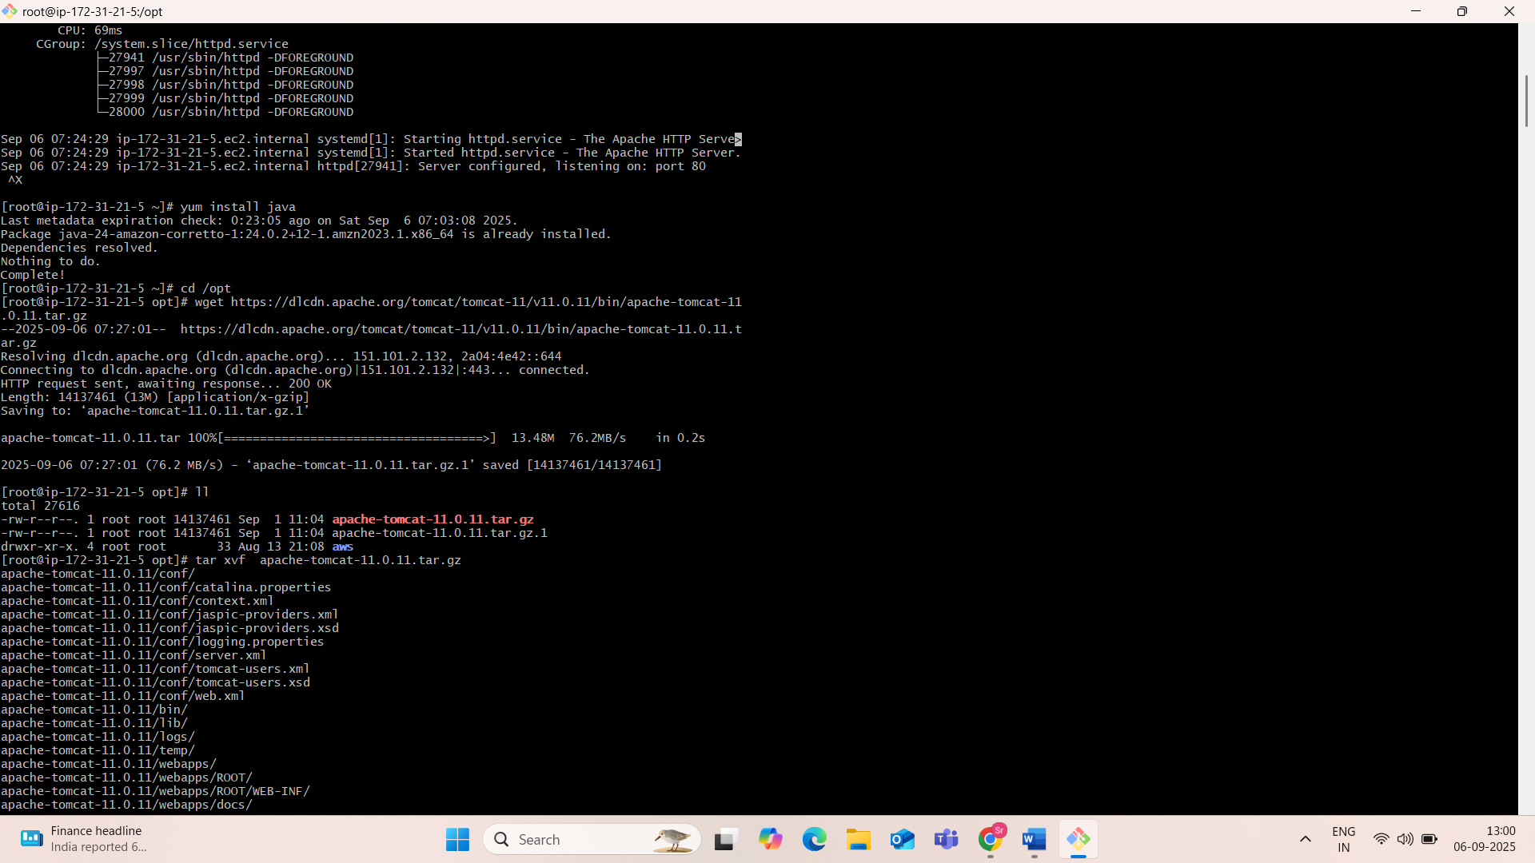

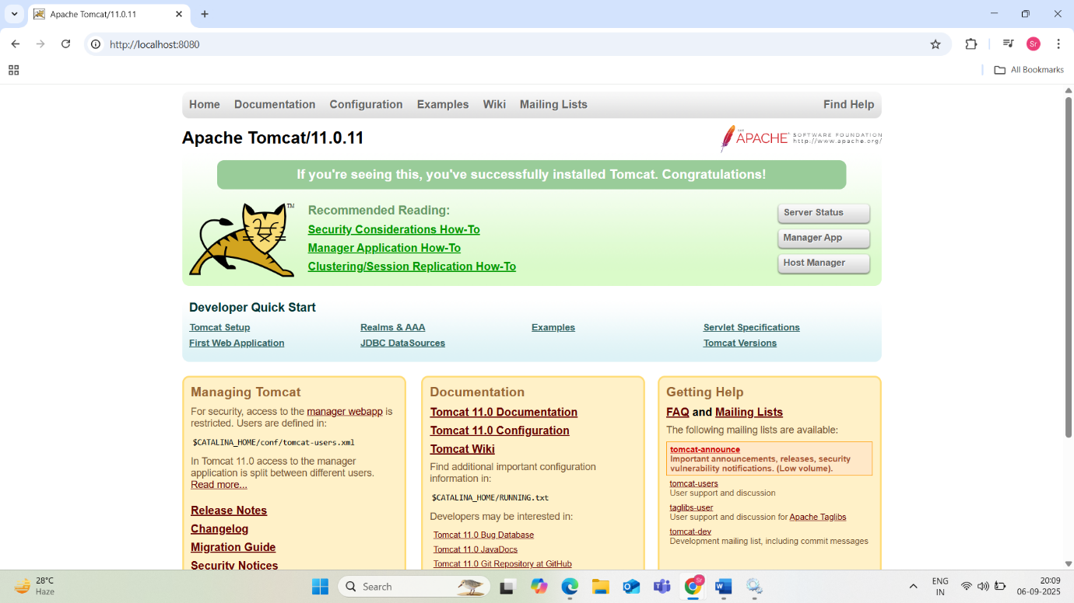

7) Create a tomcat.service file for tomcat.

A tomcat.service file is a systemd unit file used to manage Apache Tomcat as a service on Linux systems. This allows for easy starting, stopping, and enabling Tomcat to run at boot.

Here is a basic example of a tomcat.service file:

Code

[Unit]  
Description=Apache Tomcat Web Application Server  
After=network.target  
  
[Service]  
Type=forking  
User=tomcat  
Group=tomcat  
Environment="JAVA_HOME=/usr/lib/jvm/java-11-openjdk-amd64" # Adjust JAVA_HOME as needed  
Environment="CATALINA_HOME=/opt/tomcat" # Adjust CATALINA_HOME as needed  
ExecStart=/opt/tomcat/bin/startup.sh  
ExecStop=/opt/tomcat/bin/shutdown.sh  
ExecReload=/opt/tomcat/bin/shutdown.sh && /opt/tomcat/bin/startup.sh  
RestartSec=10  
Restart=always  
  
[Install]  
WantedBy=multi-user.target

Explanation of the sections:

* **[Unit]**:
  + Description: Provides a brief description of the service.
  + After: Specifies that this service should start after the network is available.
* **[Service]**:
  + Type=forking: Indicates that the service will fork a process.
  + User and Group: Define the user and group under which Tomcat will run. It is recommended to create a dedicated user (e.g., tomcat) for security.
  + Environment: Sets environment variables required by Tomcat, such as JAVA_HOME (the path to your Java Development Kit) and CATALINA_HOME (the root directory of your Tomcat installation). Ensure these paths are correct for your system.
  + ExecStart: The command to execute when the service starts (Tomcat's startup.sh script).
  + ExecStop: The command to execute when the service stops (Tomcat's shutdown.sh script).
  + ExecReload: The command to execute when the service is reloaded. This example performs a stop and then a start.
  + RestartSec: Specifies the time to wait before restarting the service if it fails.
  + Restart=always: Ensures the service automatically restarts if it crashes.
* **[Install]**:
  + WantedBy=multi-user.target: Defines the target that this service is part of, ensuring it starts when the system reaches the multi-user state (normal boot).

To use this file:

* Save the content above as tomcat.service in the /etc/systemd/system/ directory.
* Adjust JAVA_HOME and CATALINA_HOME to match your actual installation paths.
* Reload the systemd daemon: sudo systemctl daemon-reload
* Enable the service to start on boot: sudo systemctl enable tomcat.service
* Start the Tomcat service: sudo systemctl start tomcat.service
* Check the service status: sudo systemctl status tomcat.service

Installation and configuration of tomcat in aws ubuntu

First connect to ec2 instance,then update using command sudo apt update or sudo apt-get update,now change to root directory “sudo su –“ next “cd /opt” , wget cpypaste the tar.gz from web browser([tar.gz](https://dlcdn.apache.org/tomcat/tomcat-11/v11.0.11/bin/apache-tomcat-11.0.11.tar.gz) ([pgp](https://downloads.apache.org/tomcat/tomcat-11/v11.0.11/bin/apache-tomcat-11.0.11.tar.gz.asc), [sha512](https://downloads.apache.org/tomcat/tomcat-11/v11.0.11/bin/apache-tomcat-11.0.11.tar.gz.sha512)) tar.gz (pgp, sha512)

* Ls
* Tar -xvzf copypaste tar.zp files from list of files( that maybe apache-tomcat-10.1.31.tar.gz)
* Ls
* Move the printed bluecolor file to tomcat: mv apache-tomcat—10.1.31 tomcat
* Ls
* Cd tomcat/
* Ls
* Cd bin
* Ls
* ./startup.sh
* Sudo apt install openjdk-11-jre-headless
* ./startup.sh(o/p:tomcat started)
* Go to ec2----->security---->security group----->click on link--🡪edit inboundrules--->custom tcp;8080;0.0.0.0/0;save rules
* Copy publick address and paste in wevb browser…u will see the apache tomcat page
* Goto ubuntu terminal : find / -name context.xml
* Copypaste: vi /opt/tomcat/webpaper/manager/META-INF/context.xml
* Edit content
* Vi /opt/tomcat/webpaper/host-/manager/META-INF/context.xml
* ./shutdown.sh
* ./startup.sh
* Goto instace and copy public key and paste it on web browser…now u can open the manager app…give username and password and signin(we can also add useradd tomcat and enter,passwd tomcat enter
* Newpasswd…chown -R tomcat /opt/apachetomcat 9.0 )
* o/p:tomcat started
* pwd
* cd .. (go back from bin)
* ls
* cd conf/
* ls
* vi tomcat-user.xml
* edit content
* :wq
* Cd ../bin/
* Ls -l
* ./shutdown.sh
* ./startup.sh
* Goto instance and copy public add and paste in web browser
* Open managerapp:username and password:o/p:html page
* manager/META-INF/context.xml

8) Configure HA Proxy server

Configuring an HAProxy server involves defining its behavior for load balancing and proxying. The primary configuration file is typically located at /etc/haproxy/haproxy.cfg.

A basic HAProxy configuration includes:

* **Global Section**:
  + Defines global parameters like logging, user/group privileges, and performance settings.
  + Example:

Code

global  
 log /dev/log local0  
 chroot /var/lib/haproxy  
 user haproxy  
 group haproxy  
 daemon  
 stats socket /run/haproxy/admin.sock mode 660 level admin expose-fd listeners  
 maxconn 25000

* **Defaults Section**:
  + Sets default parameters for all listen, frontend, and backend sections, such as timeouts and logging.
  + Example:

Code

defaults  
 mode http  
 log global  
 option httplog  
 option dontlognull  
 timeout connect 5000ms  
 timeout client 50000ms  
 timeout server 50000ms

* **Frontend Section**:
  + Defines the public-facing listener for incoming client connections, including the IP address and port HAProxy will listen on.
  + Example:

Code

frontend my_web_frontend  
 bind *:80  
 mode http  
 default_backend web_servers

* **Backend Section**:
  + Defines the group of backend servers to which HAProxy will forward traffic. This includes the IP addresses and ports of the actual application or web servers.
  + Example:

Code

backend web_servers  
 balance roundrobin  
 server web1 192.168.1.10:80 check  
 server web2 192.168.1.11:80 check

* balance roundrobin: Specifies the load balancing algorithm (e.g., round-robin, leastconn, source).
* check: Enables health checks for the backend servers.
* **Statistics Section (Optional)**:
  + Provides a web interface to monitor HAProxy's status and server health.
  + Example:

Code

listen stats_page  
 bind *:8080  
 mode http  
 stats enable  
 stats uri /haproxy?stats  
 stats realm HAProxy\ Statistics  
 stats auth admin:password

After modifying the configuration file, reload or restart the HAProxy service for the changes to take effect.

Code

sudo systemctl restart haproxy

step1: launch 3ec2 instances 1)server1 2)server 3) HA-proxy-server

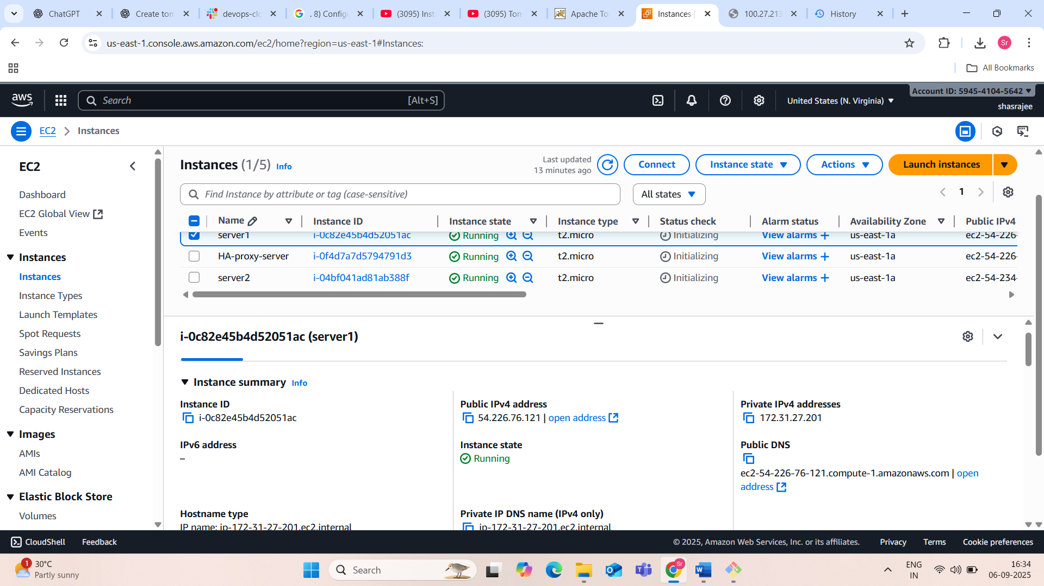

Step2:work on server1

Connect to server1 to amazon ec2 instance server using : Ssh -i server1.pem ec2-user@copy the ipv4 pub address

Update ur server: sudo yum update

Switch to root user:sudo su – (or) sudo -i

Again u can update

